CHAPTER 2
PLANNING

The term "planning" in building construction refers to the strategic arrangement of all building units across all floors and levels. It encompasses not only the horizontal layout but also the vertical elevation, ensuring that the spaces enclosed by walls, floors, and roofs are optimized for their intended use.
During the planning phase, it is critical to keep the general purpose of the building at the forefront. Because each building type has unique requirements to fulfill its purpose effectively, deep consideration must be given to the functional and utility aspects of the design. For this specific Indiramma Illu housing scheme project, the design focuses on maximizing space utility for multiple residential flats while adhering to statutory regulations.
The main considerations guiding this planning process include:
- Human habitation needs and spatial requirements.
- Climatic conditions and their effects on ventilation and lighting.
- Adherence to Building Bye-laws for legal planning and construction.
- Available finance and economic feasibility.
- Overall comfort, safety, and structural economy.
2.1 Road Widening Width Proper road access is essential for future urban development. The specification for the road widening width is adopted from G.O.Ms.No.168. According to these guidelines, a road widening width for future road development must be provided at a minimum of 4.5 m from the center line of the existing road.
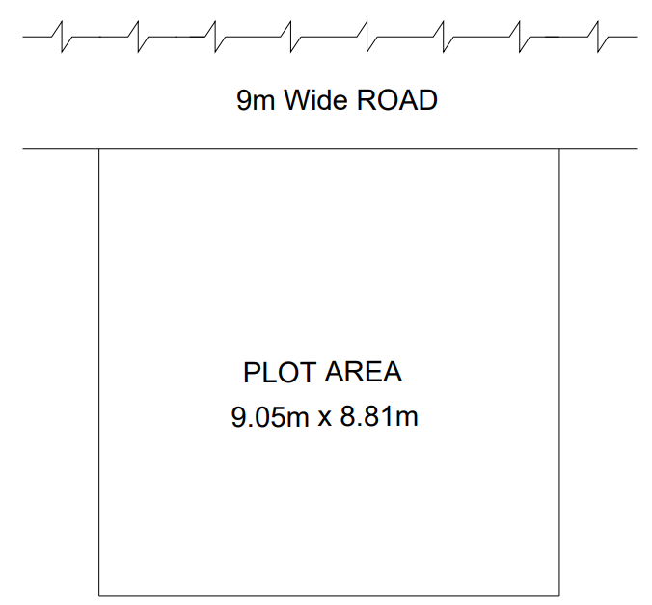
Figure 2.1: Plot area.
2.2 Setbacks Setbacks ensure adequate natural light, ventilation, and fire safety access around the structure. The specifications for setbacks are also derived from Table 3 of G.O.Ms.No.168. For this plot, a 1.5m free space is provided at the front of the building, while 0.5m of free space is maintained on the sides and the rear as setbacks.
After deducting these setbacks from the gross plot area of 9.05m x 8.81m (79.73 m²), the resulting net plot area available for the main building footprint is 8.05m x 6.81m (54.82 m²). This net area serves as the boundary for the primary structural planning.

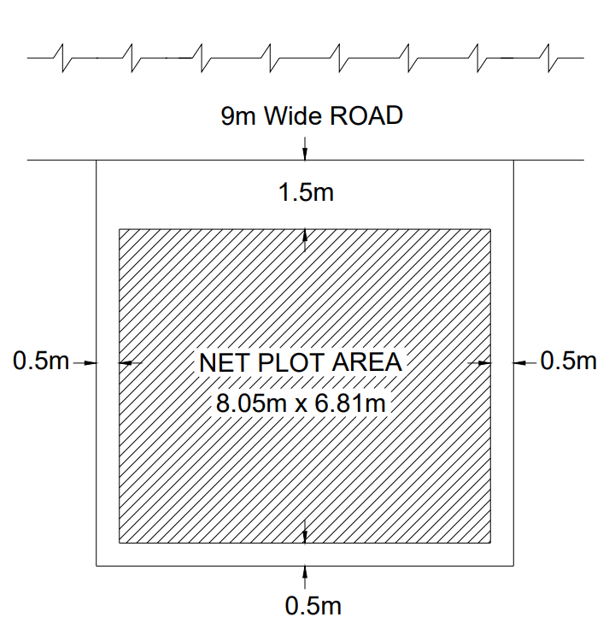
Figure 2.2: Net Plot Area.
2.3 REQUIREMENTS OF PARTS OF BUILDINGS
To ensure safety, livability, and compliance with the Telangana State Government guidelines for the Indiramma Illu Scheme, the specifications for the building's components follow the mandatory scheme provisions combined with the "National Building Code (NBC) 2016 Part 3: Development Control Rules and General Building Requirements" for Low-Income Housing (EWS).
The scheme explicitly mandates a G+0 pucca structure, an RCC roof, and a minimum built-up area of 400 sq. ft. (approx. 37.16 m²). The requirements for various parts of the building are strictly in accordance with these parameters.

2.3.1 Plinth
- Main Building: The plinth of the single-story main building must be located relative to the surrounding ground level to guarantee adequate site drainage. The height of the plinth shall not be less than 450 mm from the surrounding ground level to prevent water logging and ensure a durable foundation.
- Plinth Area Constraints: As per the scheme's standard layout guidelines, the total constructed plinth area (built-up area) must meet the minimum requirement of 400 sq. ft. to qualify for the full government financial assistance.
2.3.2 Habitable Rooms
- Height: The vertical clearance of all human habitation rooms must not be less than 2.75 m, measured from the finished floor surface to the lowest point of the ceiling (bottom of the RCC slab). The clear headroom under any structural beam shall be at least 2.4 m.
- Size: To fit efficiently within the 400 sq. ft. layout, the primary habitable room shall have an area of not less than 9.5 m² with a minimum width of 2.4 m. For the secondary room (bedroom), the area must be at least 7.5 m², with a minimum width of 2.1 m.
2.3.3 Kitchen
- Height: Kitchen height must not be less than 2.75 m from the floor to the lowest ceiling point.
- Size: A separate kitchen is a mandatory inclusion under the Indiramma Illu scheme. The kitchen must have a minimum floor area of 4.5 m² (or 3.3 m² as per minimum EWS standards to conserve space) with a minimum width of 1.5 m.
- Other Requirements: Every kitchen must have a proper sink connected to a grated waste pipe, an impermeable floor, and adequate ventilation openings as specified by NBC 20.1.1.
2.3.4 Bathrooms and Water-Closet
- Height: Minimum height is 2.1 m from floor to ceiling.
- Size: A sanitary toilet facility is mandatory. Independent bathrooms must be at least 1.8 m² (minimum width 1.2 m), and independent water-closets must be 1.1 m² (minimum width 0.9 m). Combined bath and water-closet units, as utilized in this plan to optimize the 400 sq. ft. footprint, must have a floor area of not less than 2.8 m² with a minimum width of 1.2 m.
- Other Requirements: At least one wall must open to the external air. Surfaces must be impervious up to 1 m high, and floors must slope toward the drain. A ventilation shaft or exhaust opening of at least 0.3 m² is required.

2.3.5 Parapet and Roof
- Roof Specification: An RCC (Reinforced Cement Concrete) roof is strictly mandatory for this scheme to ensure a permanent, weather-resistant structure.
- Parapet: Parapet walls on the RCC roof edges shall be maintained between 1.0 m and 1.2 m in height from the finished floor level for optimal safety.
2.3.6 Boundary Wall
Standard boundary walls around the allotted plot (typically 250 sq. yards for landless beneficiaries) should have a maximum height of 1.5 m above the front street's center line. Corner plots restrict solid boundary wall heights to 0.75 m for a length of 10 m at intersections to maintain clear sightlines for traffic.
2.3.7 Staircase
- Minimum clear width: As this is a G+0 single-family low-cost dwelling, an internal or external staircase may be provided strictly for access to the RCC roof (allowing for future vertical expansion by the beneficiary). Following NBC standards for Low-Income Housing (EWS), a minimum clear width of 0.9 m is sufficient.
- Treads & Risers: The minimum tread width is optimized to 250 mm for single-family dwellings. To conserve space within the plot footprint, the maximum riser height can be up to 190 mm.
- Headroom: A minimum clear headroom of 2.2 m must be maintained throughout the staircase flight and under any landings.
2.3.8 Exit Requirements Given the single-story (G+0) nature and the compact 400 sq. ft. footprint of the dwelling, complex corridor routing is not applicable. Exit requirements are straightforwardly met through direct access from the main living area to the exterior. All door placements and widths are designed to ensure immediate, unobstructed egress to the outside to ensure rapid evacuation capabilities.
2.4 Plinth & Carpet Area Applying the mandatory scheme specifications to the allotted plot area, the designed layout achieves a highly efficient footprint that maximizes the living space while remaining strictly within the budget and guidelines. We have established a total plinth area (built-up area) of exactly 400 sq. ft. (approx. 37.16 m²) to qualify for the full government financial assistance.
Subtracting the area occupied by the external and internal walls, the floor plan yields an optimized net carpet area.
The ground floor layout details the spatial arrangement of the mandatory components: the primary living area, the bedroom, the separate kitchen, and the combined bath/WC unit. This arrangement optimizes internal circulation, natural lighting, and cross-ventilation within the compact boundary, as detailed in the AutoCAD floor plans in Figure 2.3.

